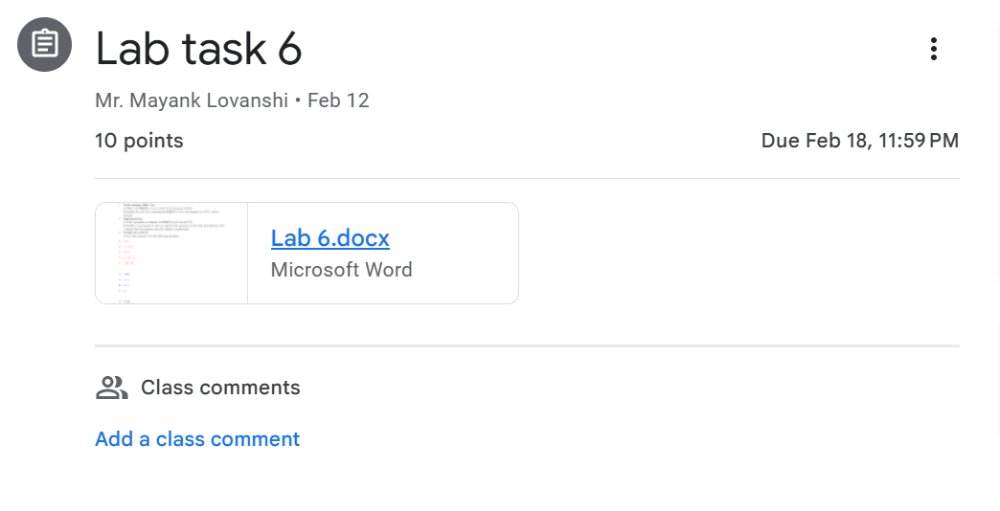

from collections import defaultdict

*def* find(*grammar*):

    first = defaultdict(set)

*def* first_rec(*sym*):

        if *sym* in first and first[*sym*]:

            return first[*sym*]

        if *sym* not in *grammar*:

            return {*sym*}

        result = set()

        for prods in *grammar*[*sym*]:

            if prods == "ε":

                result.add("ε")

            else:

                empty = True

                for i, part in enumerate(prods.split()):

                    part_first = first_rec(part)

                    result.update(part_first - {"ε"})

                    if "ε" not in part_first:

                        empty = False

                        break

                if empty:

                    result.add("ε")

        first[*sym*] = result

        return result

    for non_terminal in *grammar*:

        first_rec(non_terminal)

    return {k: first[k] for k in *grammar*}

grammar = {

        "S": [" A "],

        "A": [" B C "],

        "B": [" x "," ε "],

        "C": [" y "," ε "],

    }

for x,y in grammar.items():

    print(x,"\t",y)

first_sets = find(grammar)

for variable, first_set in first_sets.items():

    print(*f*"FIRST({variable}) = {first_set}")

**OUTPUT**

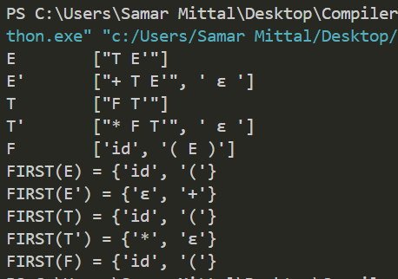

TEST CASE 1

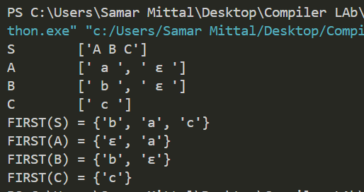

TEST CASE 2

TEST CASE 3

TEST CASE 4

